Payroll User Manual

Index
1. Login as Client service Manager

2. Add Employees in the Company

3. Adding Employees payroll details

4. Assigning Payroll Service items to the Employees

5. Process Payroll for the Company

1. Login as Client service Manager
Menu: PayrollManager
This option is used to work on the following options :
a) Company List
b) Employee List
c) Pay Settings

1. Company List

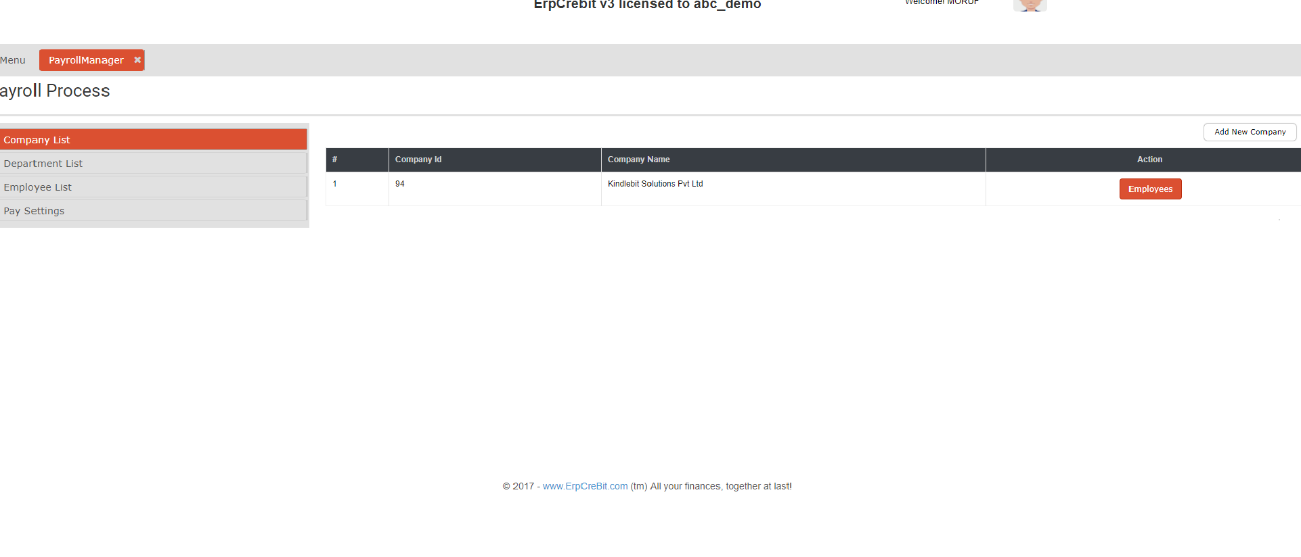
Company list allows the user to Add new Company and to manage the different companies Payroll.
This menu shows the Companies list associated with the current Login user as Client Service Manager.

To add the new company we click on add new company and fill the add new Company with fields like:
Department Name as Company Name, Address Location and Corporate.

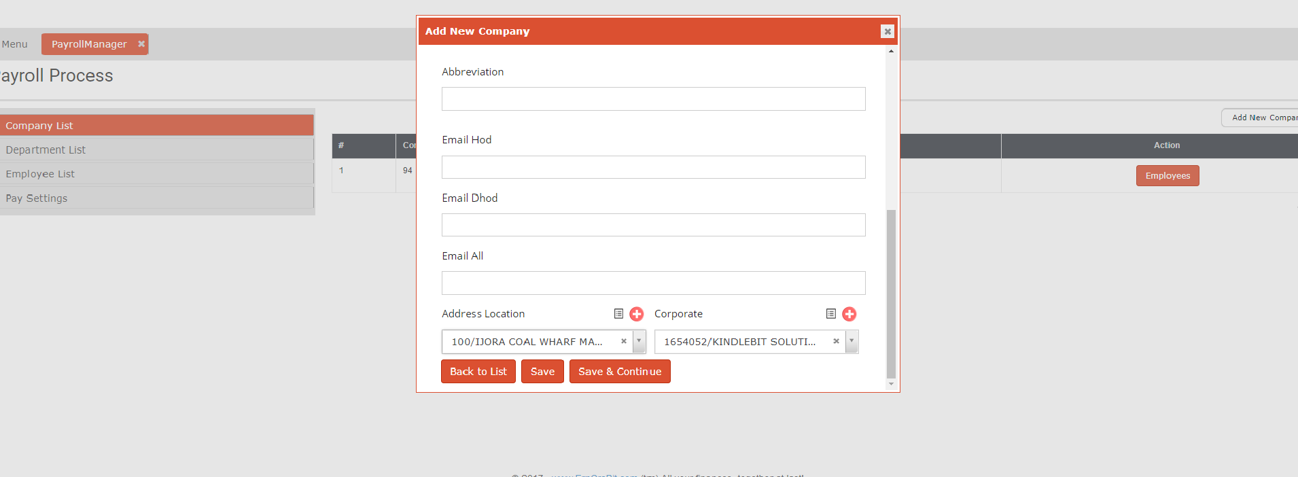

2. Add Employees in the Company
This option is used to add Employees in the selected Company, to check employees in the company select Employees, further we can add new employees under the following Employer by simply selecting on the Add new Employee button.

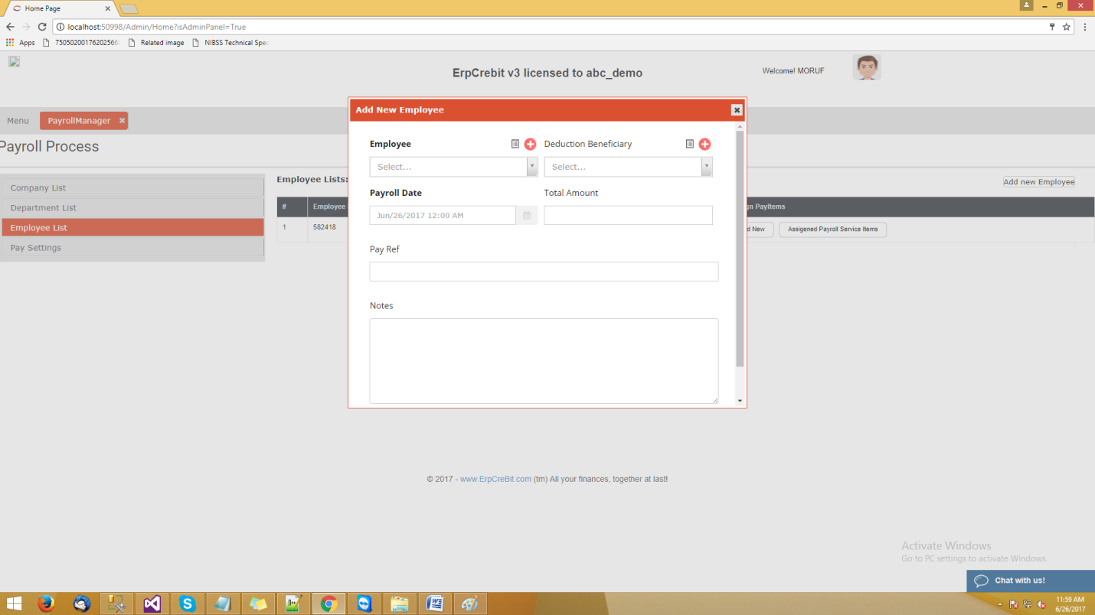

Once the Employee is successfully added it will be listed in the Employee list screen.
3. Adding Employees payroll details

Once the Employee is successfully created we need to associate the Bank account detail of the employee which will be used to do the online Payroll payments.

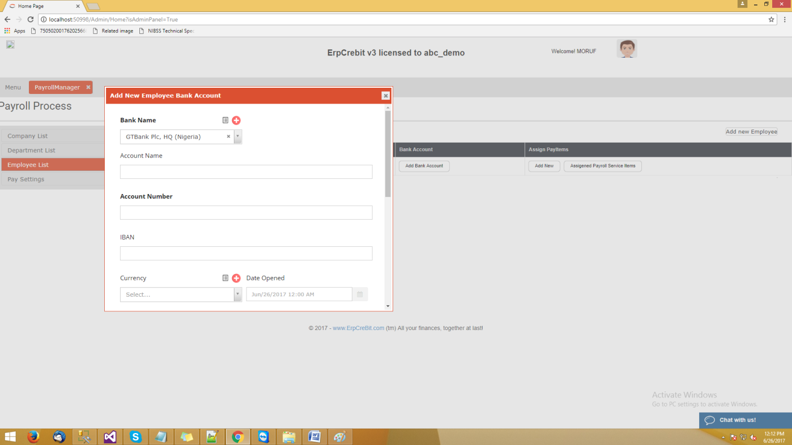

also we can edit the Bank account details if there need for some changes in the Bank account details of the employee by simply clicking on the Edit Bank account

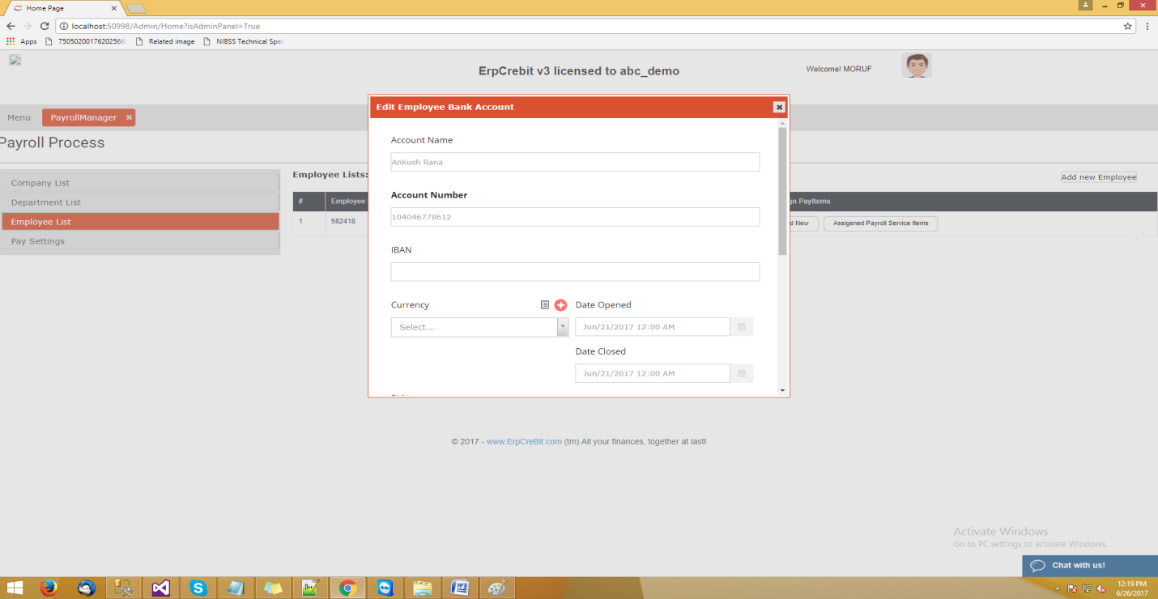

4. Assigning Payroll Service items to the Employees

The next step is to assign Payroll Service item to the Employee, we can do this by simply clicking on the Add New button on the Employee column, which will allow to us to assign multiple Pay items to the Employees , such as Basic, Meals, Lunch, Insurance..,etc

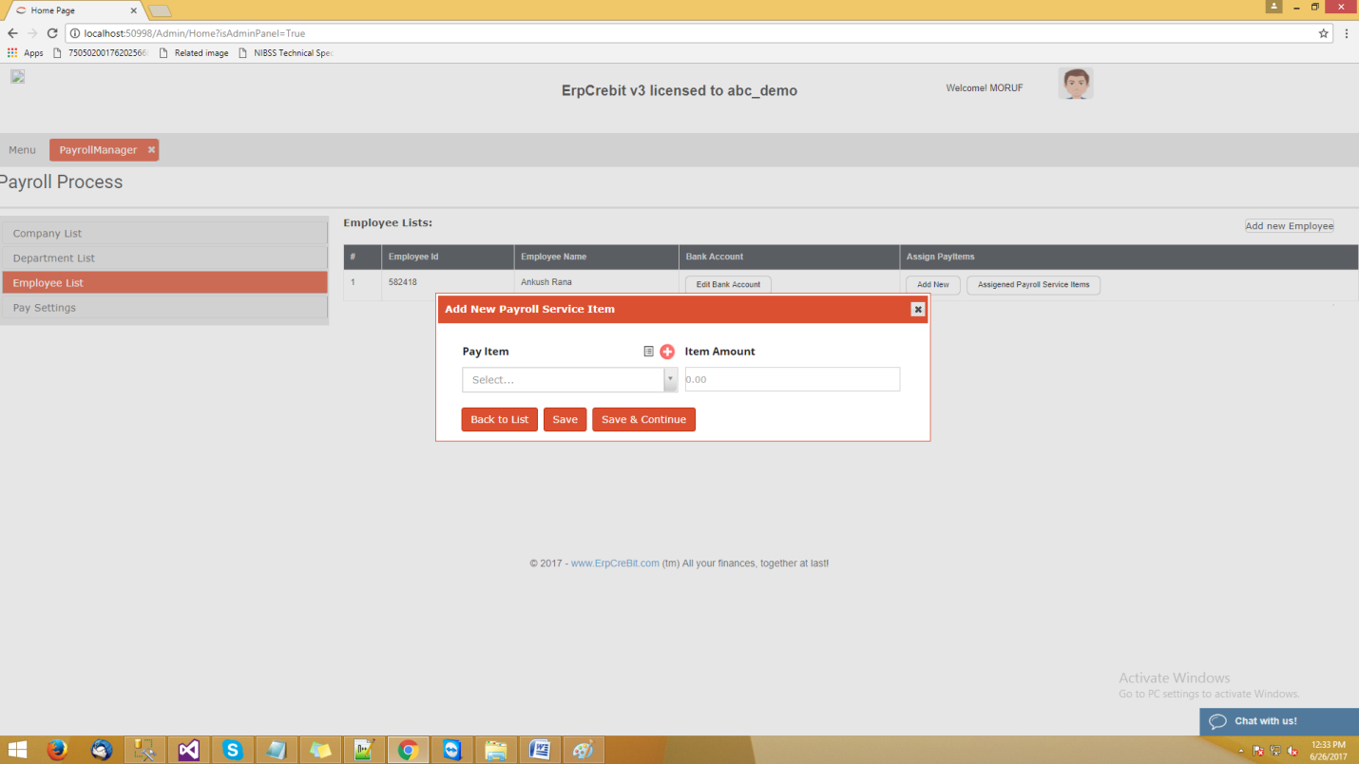

Now to check what all Pay Service Items we have for a Employee, click on Assigned Payroll Service Items and it will list all the assigned pay items in Pop Up form.

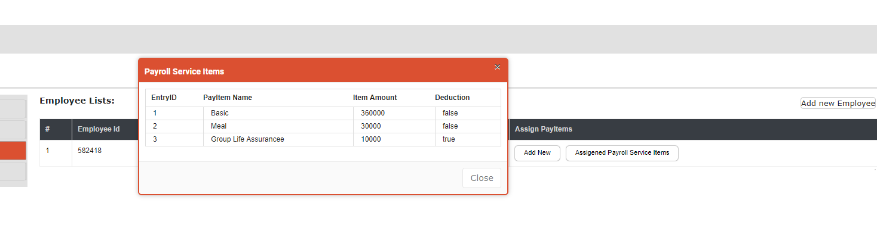

5. Process Payroll for the Company

The next step is to Process Payroll of the company, we can do this by simply selecting Company, Month, Year and click on Process Payroll.

