Prepaid Parking System

Index
1. Generate Prepaid Parking Ticket
1.1 Generate Parking Ticket
1.2 Download Parking ticket
1.3 Excel Export

2. Buy Parking Ticket
2.1 Buy Parking ticket
2.2 Assign Parking ticket
2.3 Report- Register Vehicle

3. Parking Entry

4. Parking Exit

5. Recharege Parking Ticket

1. Generate Prepaid Parking Ticket
Menu: Generate Prepaid Parking ticket
This option is used to generate parking tickets. This option is only availiable for Admin user only.

This screen is further devided in 3 sections:-

1. Generate Parking ticket

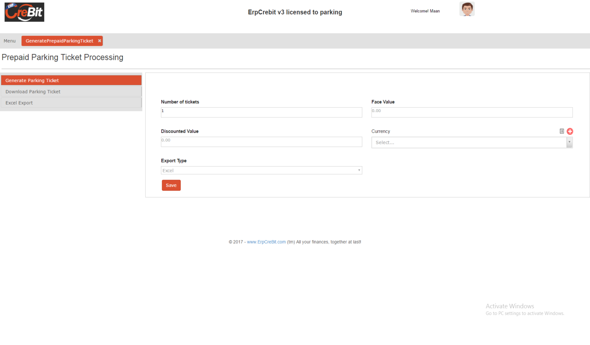
a) Number of Tickets:- Number of ticket you want to generate.
b) Face Value:- Real value of ticket and it is the same value which displayed in the ticket.
c) Discounted Value: The value which is used to sell for user.
d) Currency: Currency used with the ticket (Required)
e) Export Type: After generating ticket, it will give ticket in PDF format or Excel format.
In PDF format it will give a real ticket which can be print or in excel file all information will be shown in excel file.

2. Download Parking ticket
This option is used to download parking ticket.
Parkin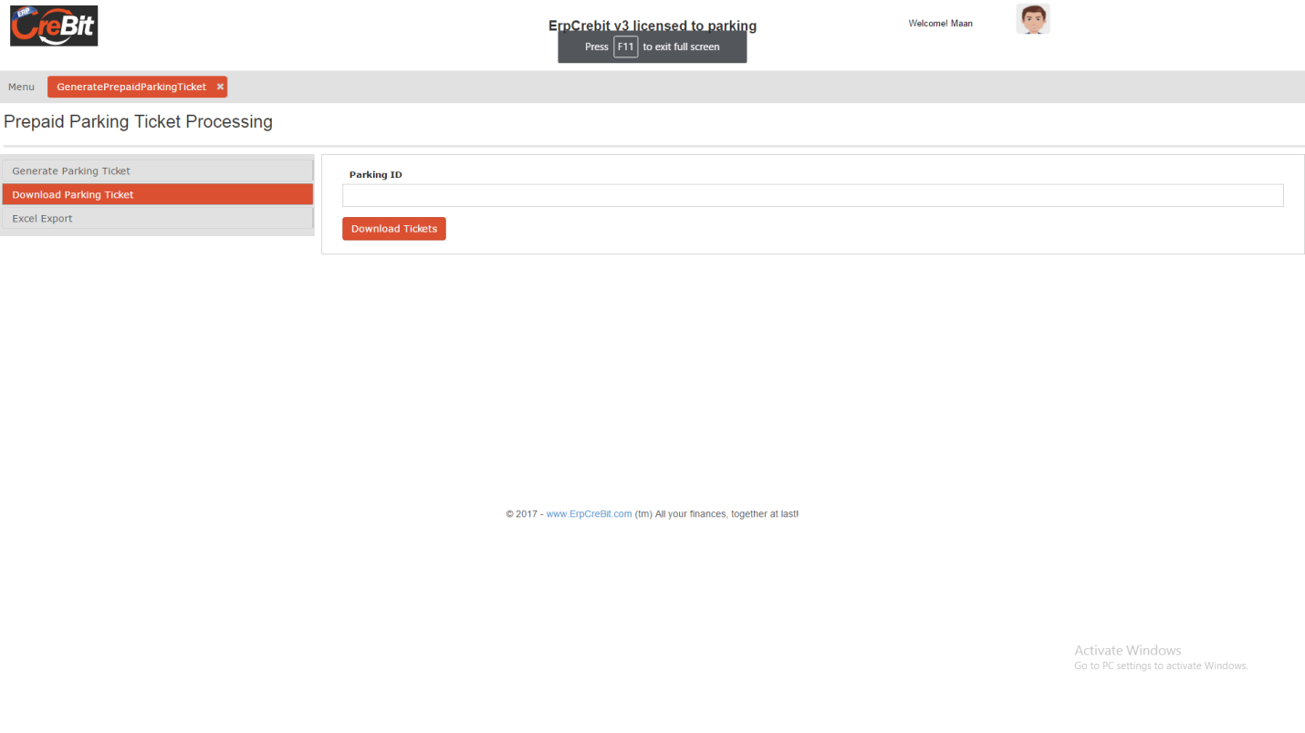
ParkingID : you can add multiple value in the text box. (e.g. 10001,10002)

3. Excel Export
Here user can export data in the excel file.
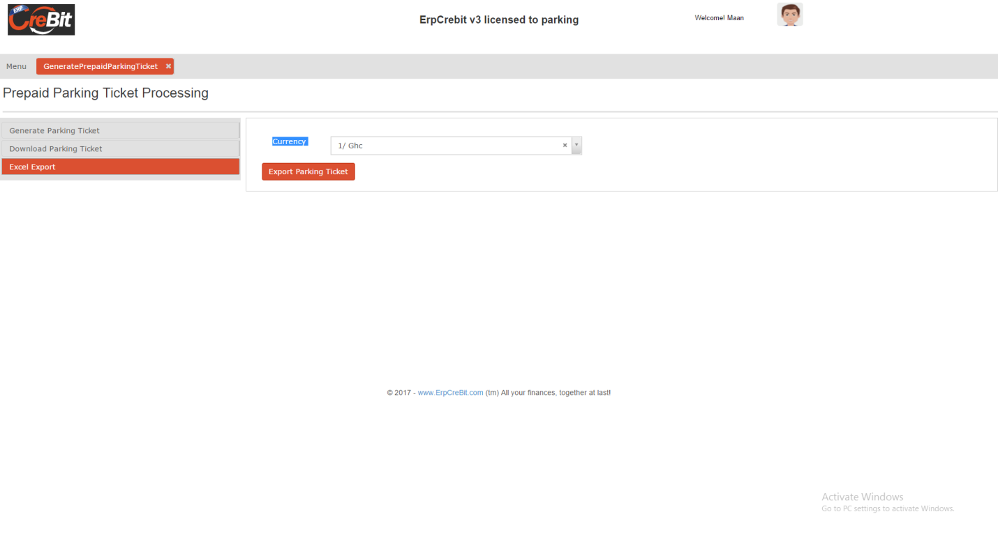
2. Buy Parking Ticket
Menu: Buy Parking Tickets

1. Buy Parking ticket
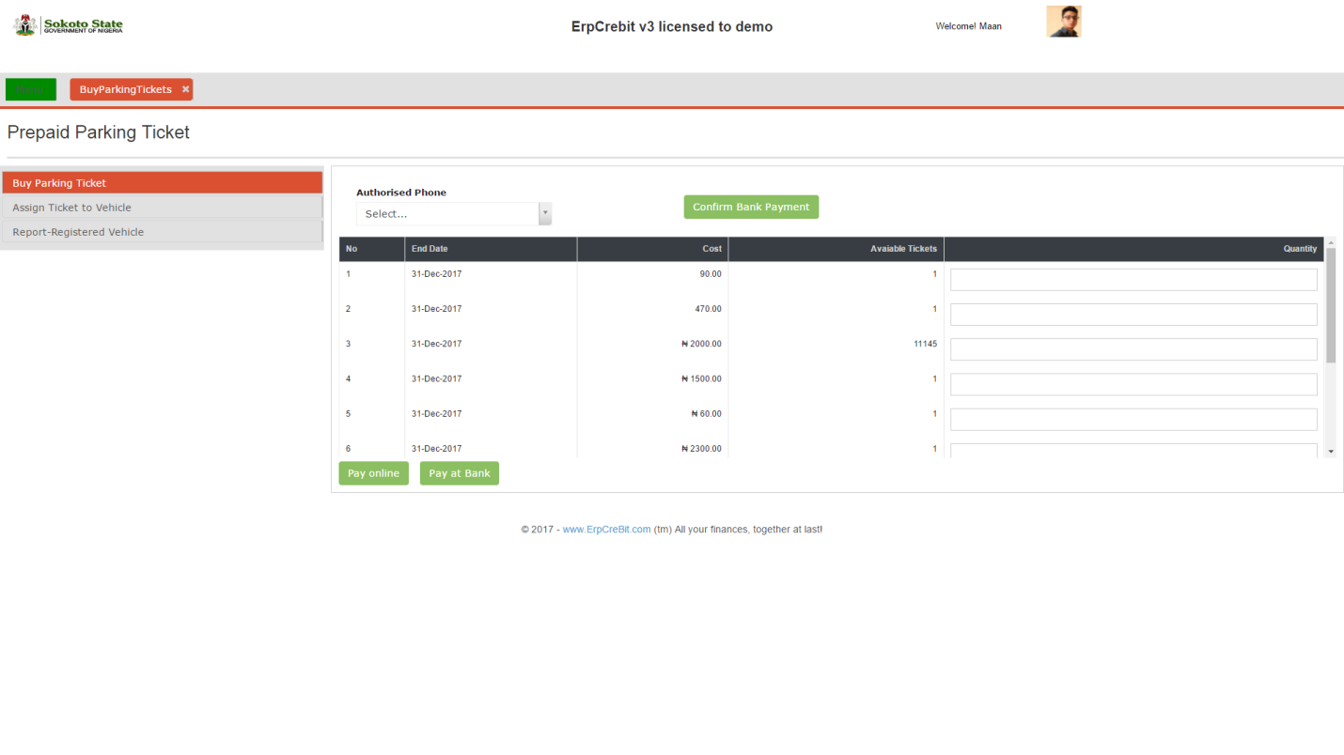
Using this tab user can buy parking ticket. Below are the steps to buy parking ticket.
1. Select Authorized phone number. (These all number belongs to current logged in user)
2. From the table put numbe of ticket you want to purchase.
3. Select Payment option
4. Make Payment
4.1 Pay Online

4.2 Pay at Bank

2. Assign Ticket to Vehicle
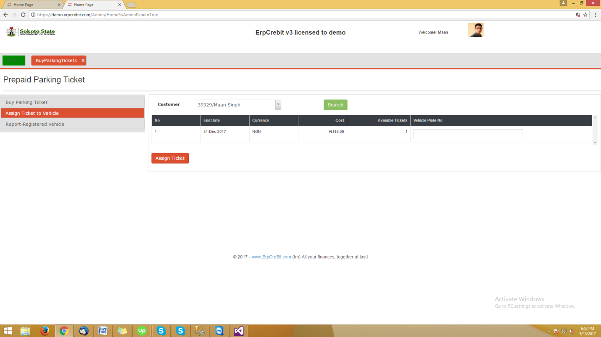
Here user willl assign parking ticket to vehicle, below are the steps:-
1. Find the ticket which you want to assign to vehicle
2. Put the vehicle Plate number in the Vehicle Plate Number column and click on assign ticket.
3. Click on the Assign Ticket.
4. If vehicle is alredy existed it will get assiged to vehicle else it will ask to create.
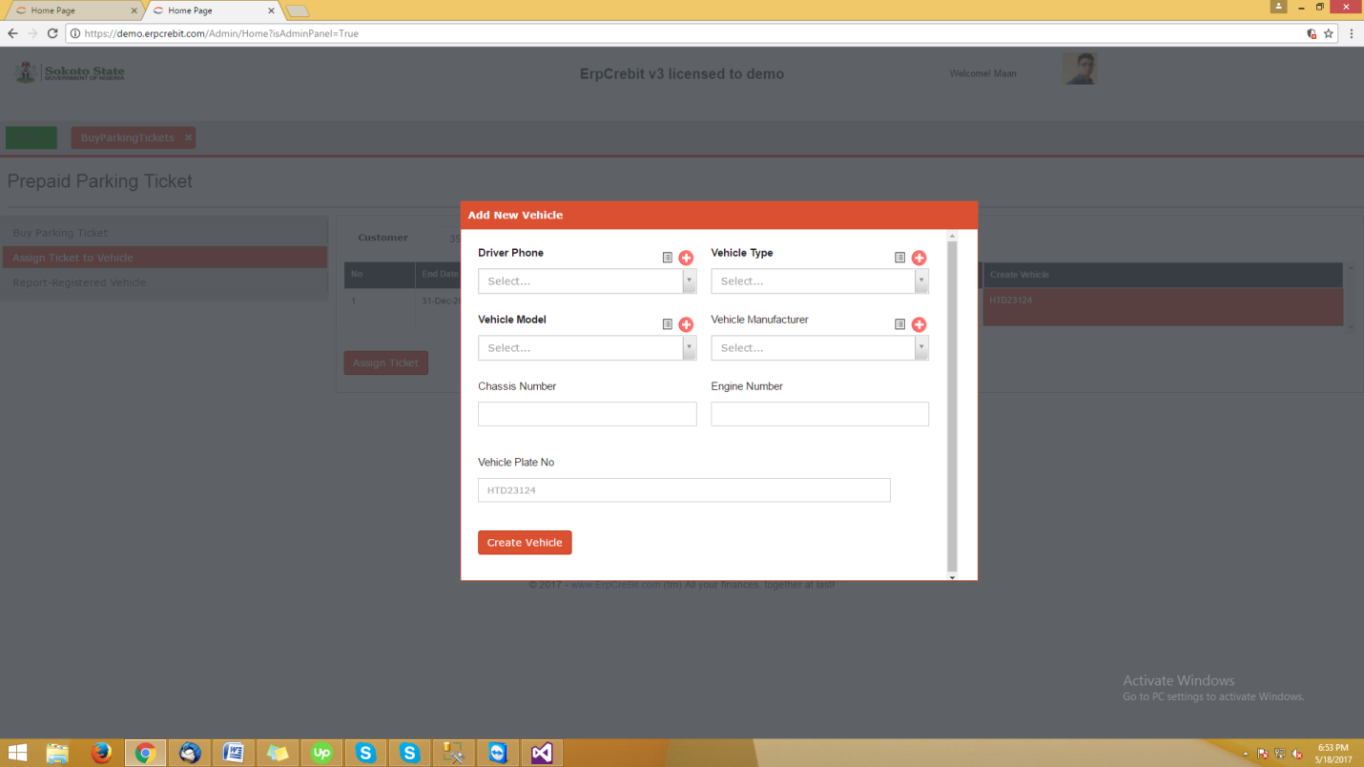

3. Report-Registered Vehicle
This option is used to get report, which helps to find the information of all assigned vehicle with the parking ticket.
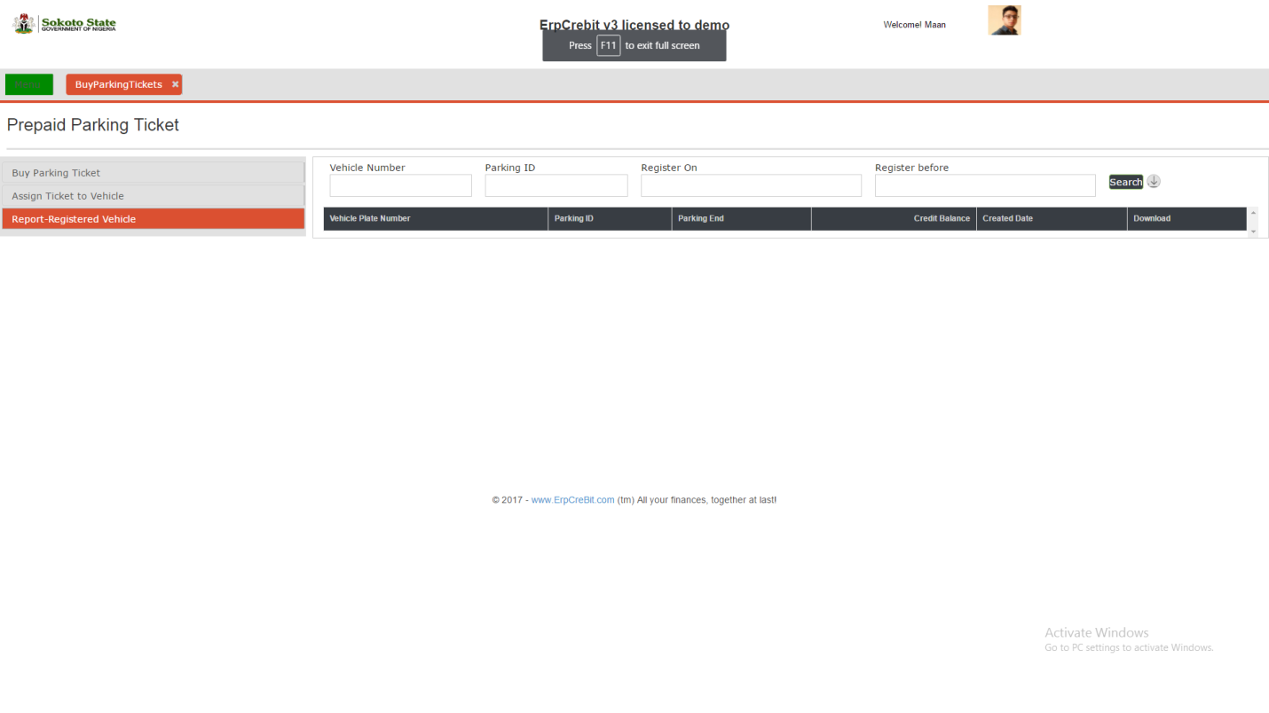

3. Parking Entry

