To link the Userdatafk wirh noncorporate or to treat the following error as below:
“Your userdatafk 2802/mailcharls@yahoo.com is not yet linked to your profile in Noncorporate”
We have to link the noncorporate with Userdatafk, following are steps below for illustration:

- After login search for the Noncorporate menu
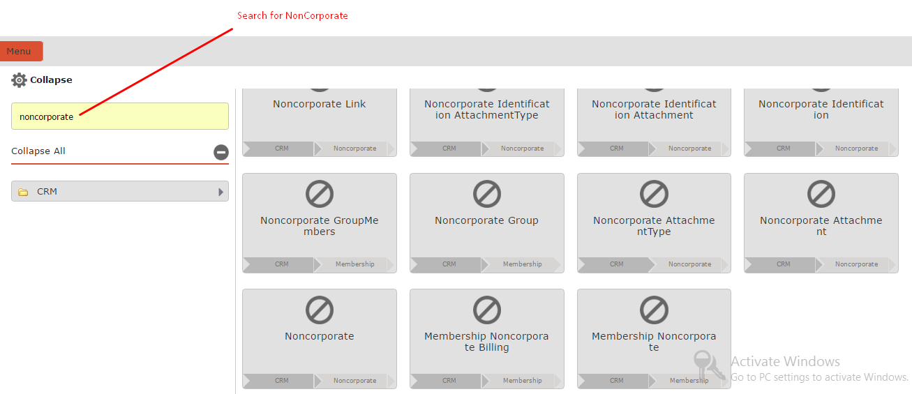

- Click on the NonCorporate menu available from the result menu
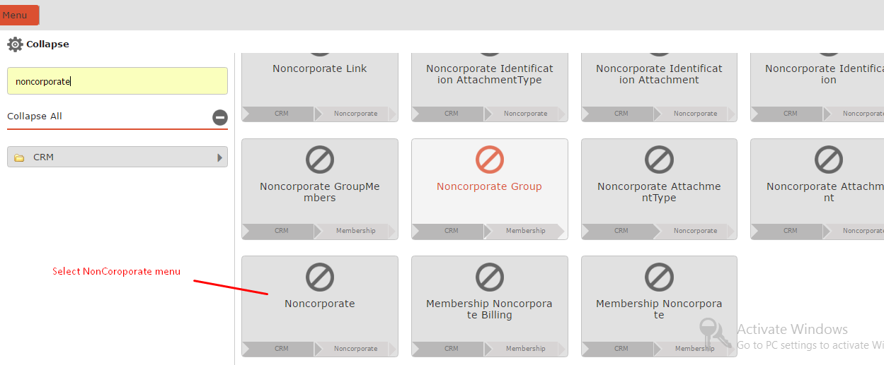

- Now search for the NonCorporate ID to be linked with UserData with either EntryId or NonCorporateFullName
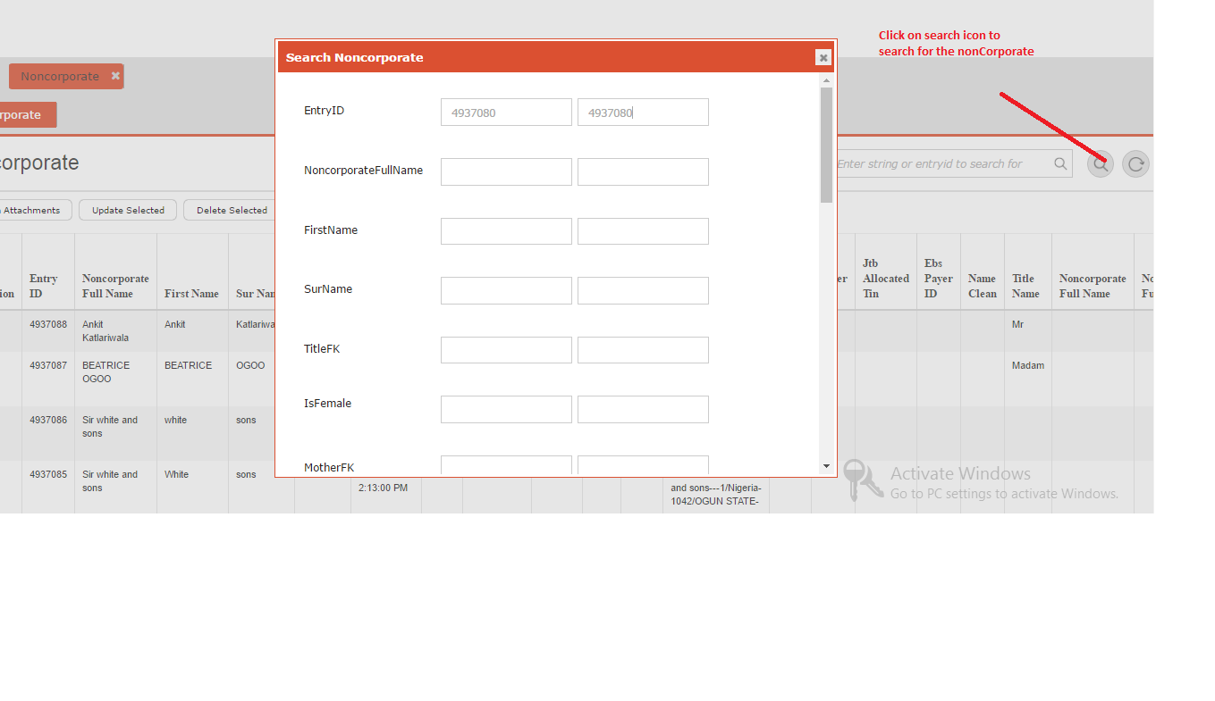

- Enter NonCorporate EntryID and click on search button below
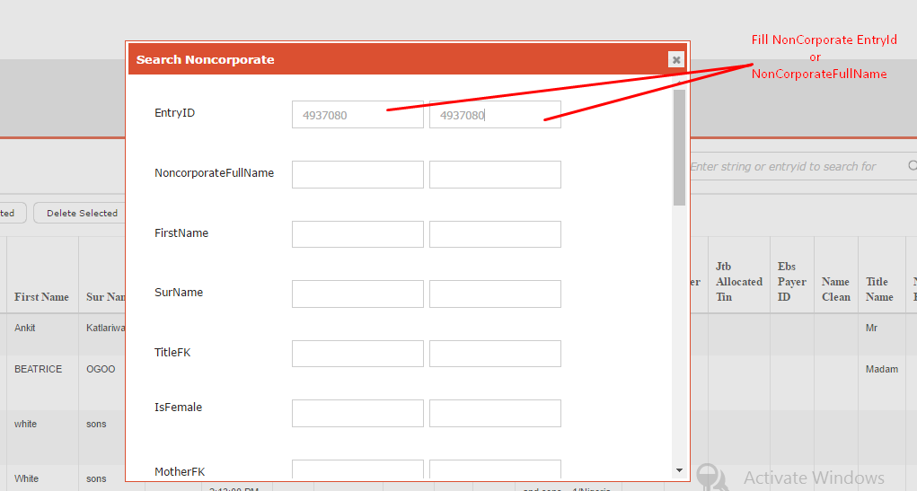

- Now select the from result to edit
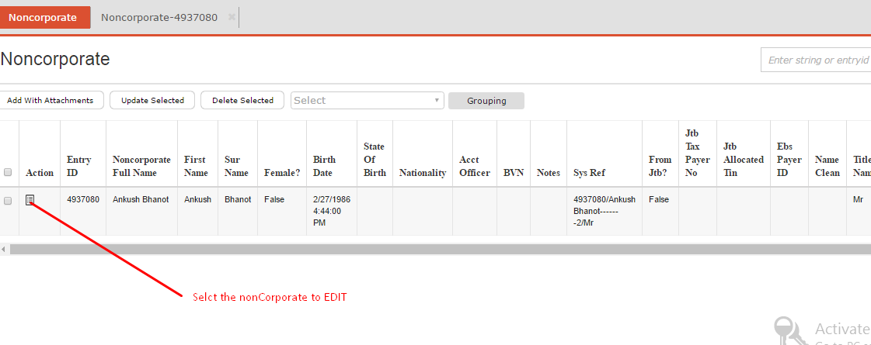

- Now edit the NonCorporate by clicking on the Edit icon
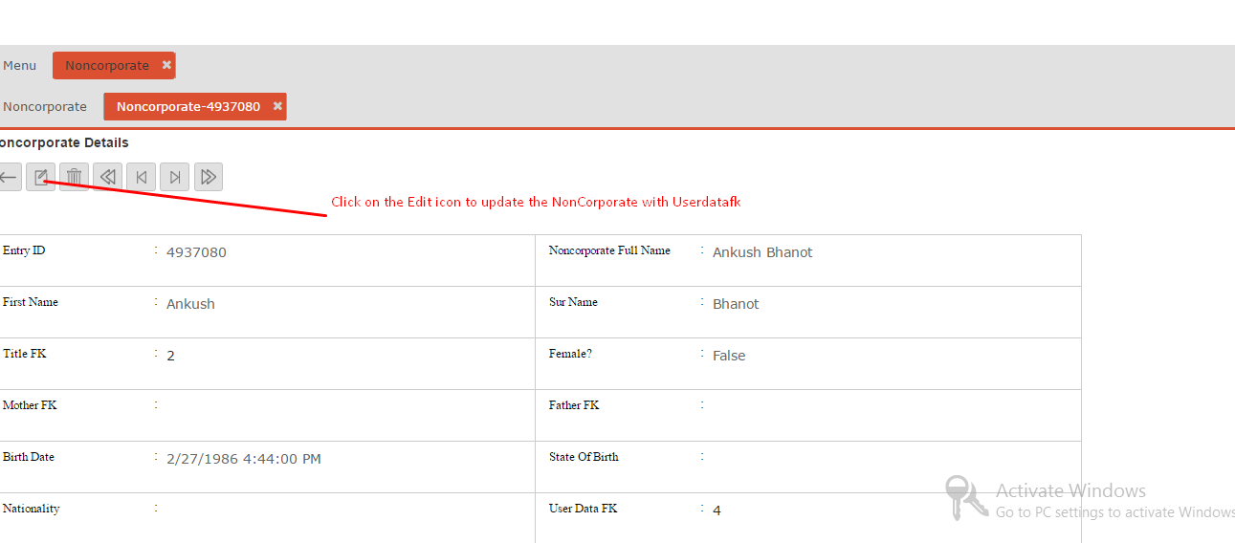

- Select the UserDatafk to be linked from dropdown and click on Update button below.
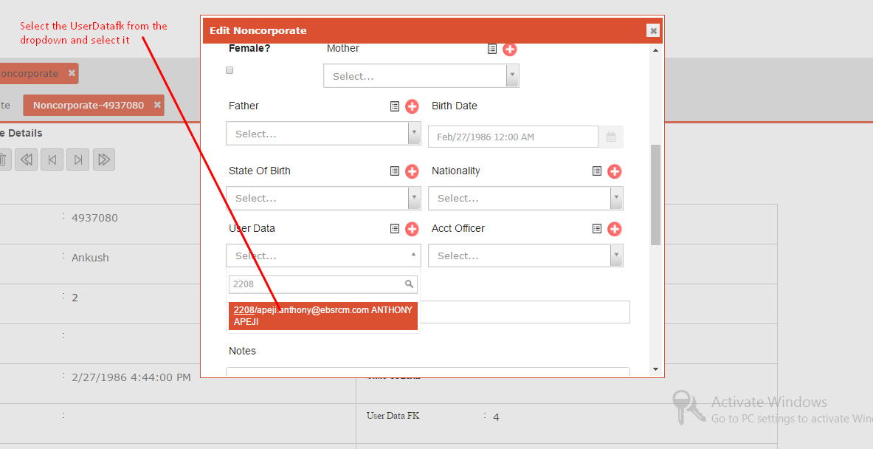

- Once record is updated the message will come as “ Record Successfully Updated ”, which will successfully link the Userdatafk with Noncorporate .

