To grant ACL permission or to treat the following error as below:
“ collinsumenwosu@yahoo.com is not authorized to insert into dbo.tbcorporate in the acl ”
We have provide the ACL permission for table, following are steps below for illustration:

- After login search for the Security Management menu
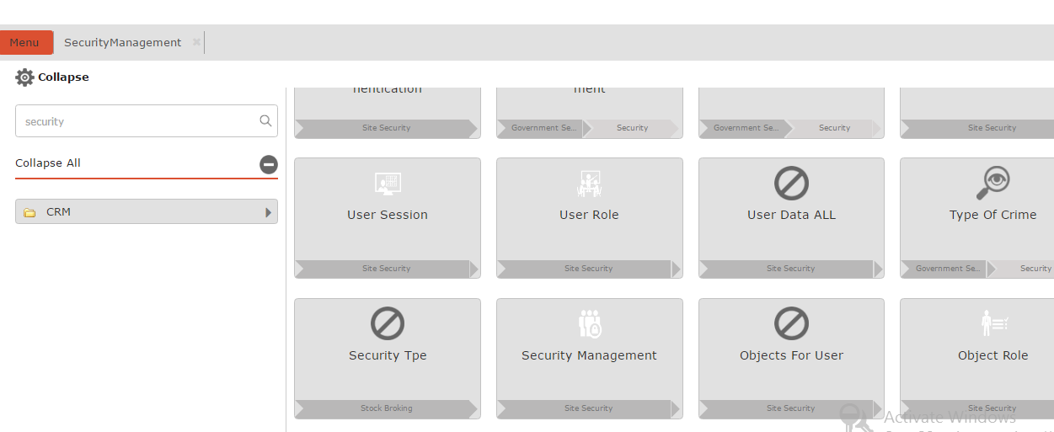

- Click on the Security Management menu available from the result menu
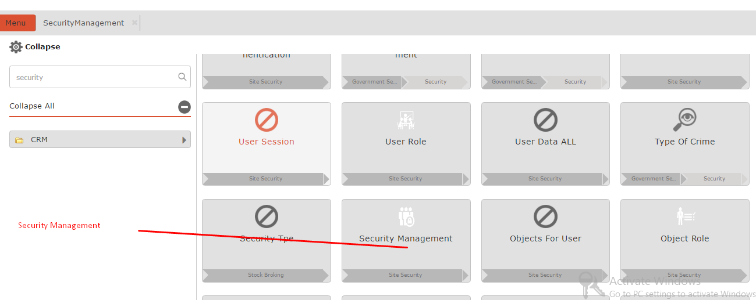

- Now fill the Security management menu with ACL Role, Objects and UserData to which ACL permission is to be given and click on Show Details

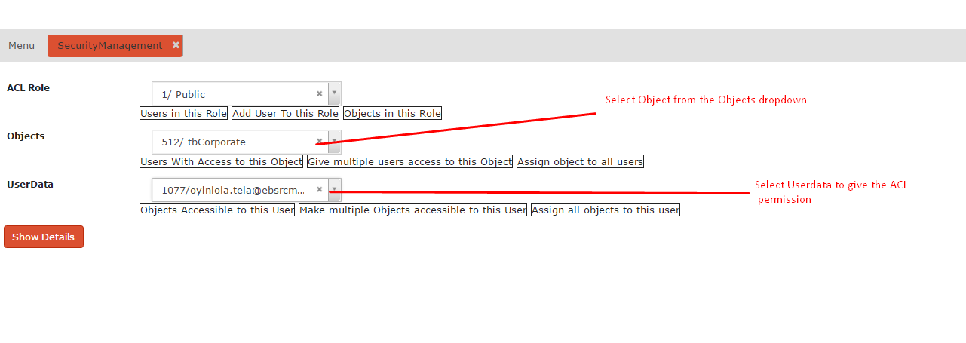

- If no such data available the pop will show the result and ask to “Add Roles”
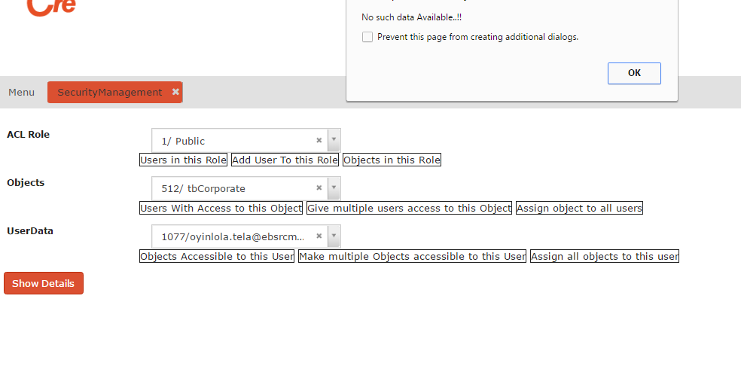

- Click on “Add Roles ” button to add ACL permission for UserData for the selected Object
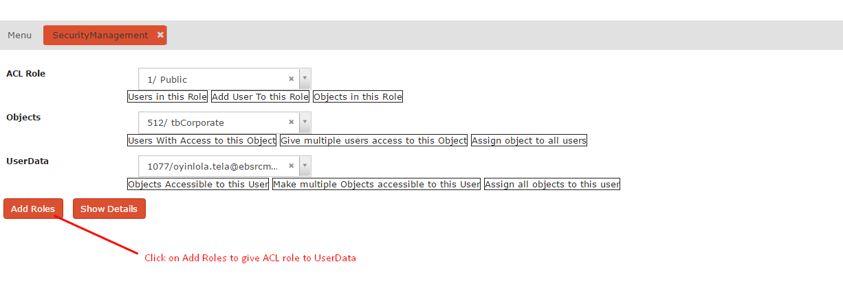
- Select the Can Insert checkbox from the Security Management popup and click on create to add ACL permission for UserData
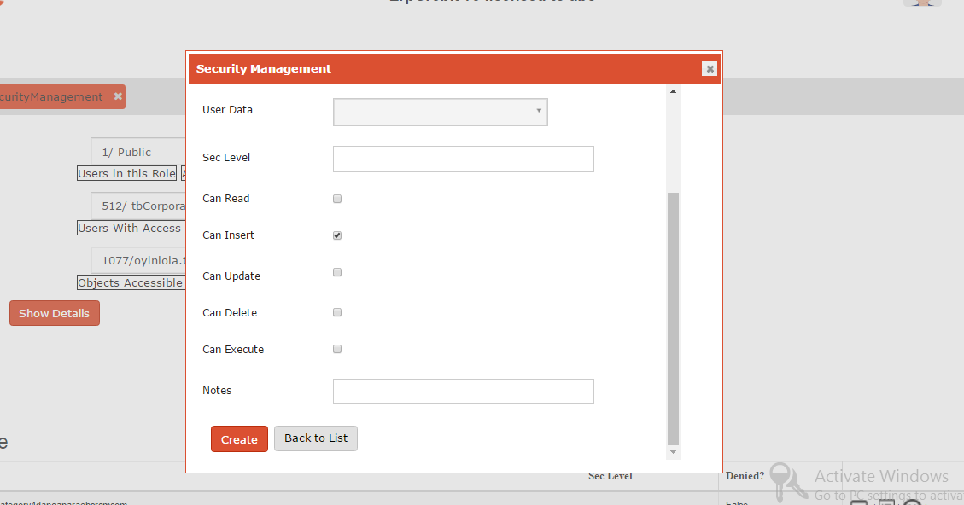

Once record is created the message will come as “Record Successfully Inserted ”, which will successfully provide the ACL permission to UserData for the table to insert .

