User manual for Payroll
Payroll-processing schedule that allows you ample time to process the payroll, following are steps below for illustration:
- After login search for the Payroll Process menu

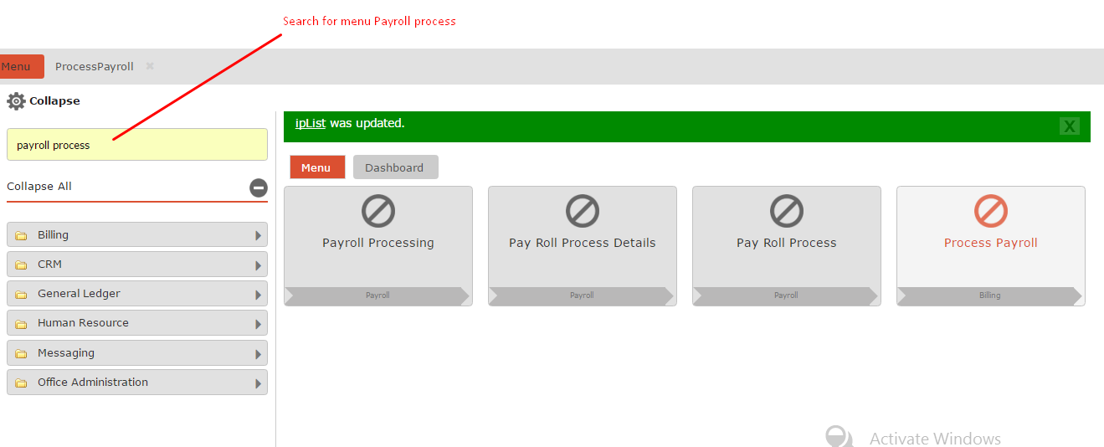

- Select the process payroll for the period which you want the payroll for different Paygroup.
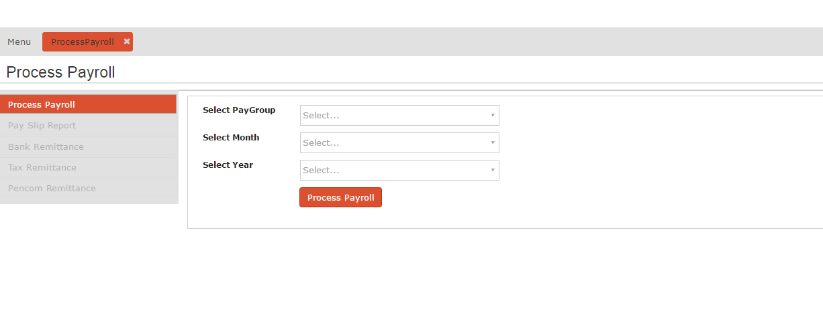

- Select the Paygroup , Month and Year for which payroll is to be processed from dropdown select menu.
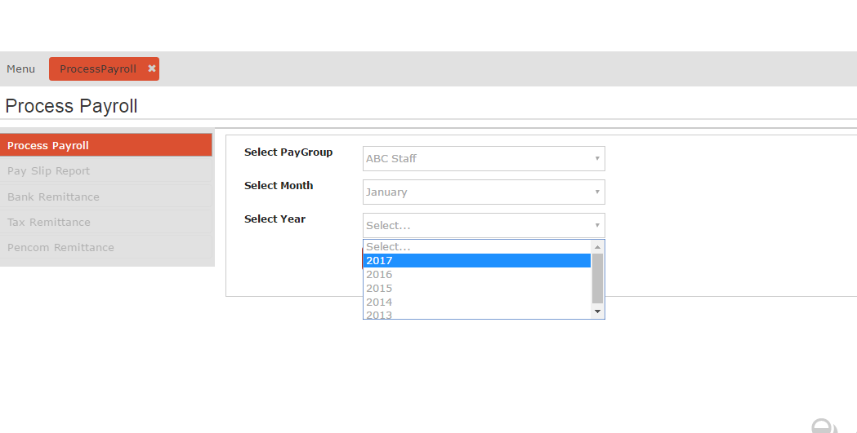

- Click on Process payroll button and confirm to process payroll.
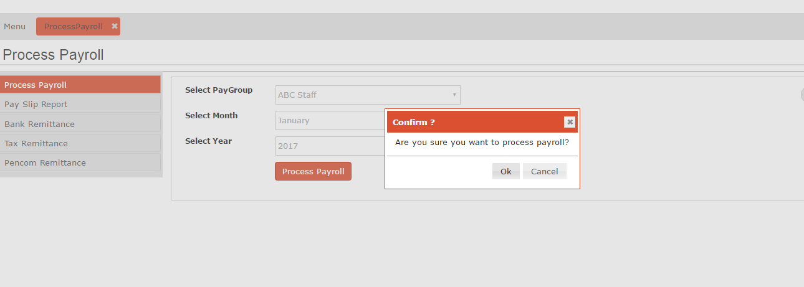

If the Payroll has been already processed for the period the message will come as “Payroll has already been processed for a succeeding period, which has to be deleted first!” To reprocess the payroll for the specific period you have to delete the Next Payroll processes.

- Once the payroll has been processed successfully , you will get the Success message and further can work on next steps like generate Pay slips, Bank Remittance Report, Tax Remittance Report and Pecom Remittance report
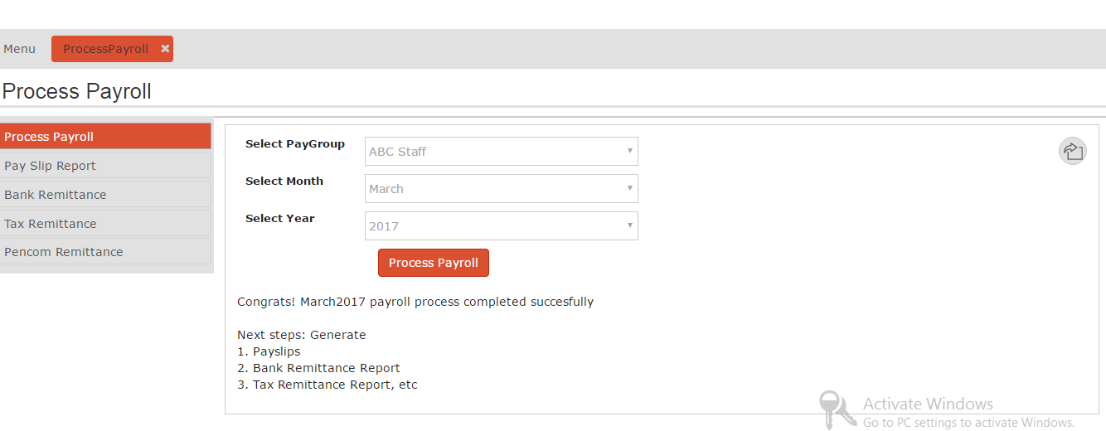

- Next Step to generate the Pay Slip click from left menu on “Pay Slip Report”. Select from the options available to generate Pay slip for Users/ Departments/ Whole Company and click on Pay slip report. We can download the Pay slips from Payslip Dashboard menu.

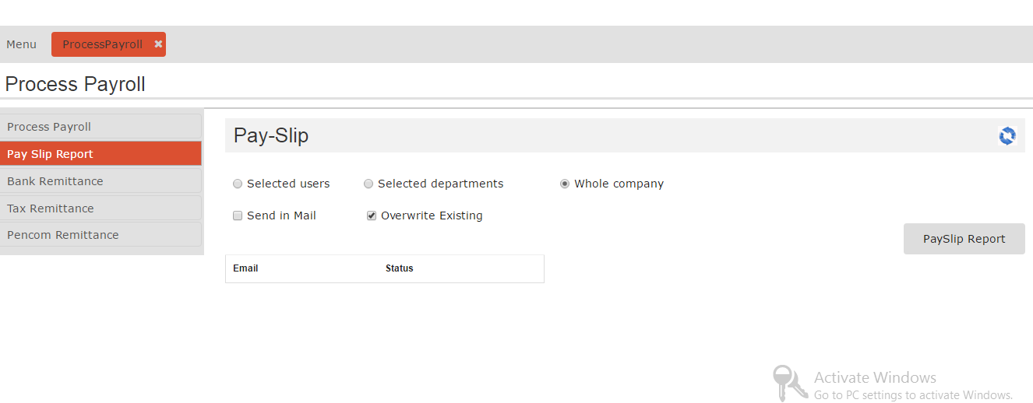

- The Pay slips can be downloaded from the menu Payroll Dashboard menu after selecting the Paygroup, Year , Month and Report.
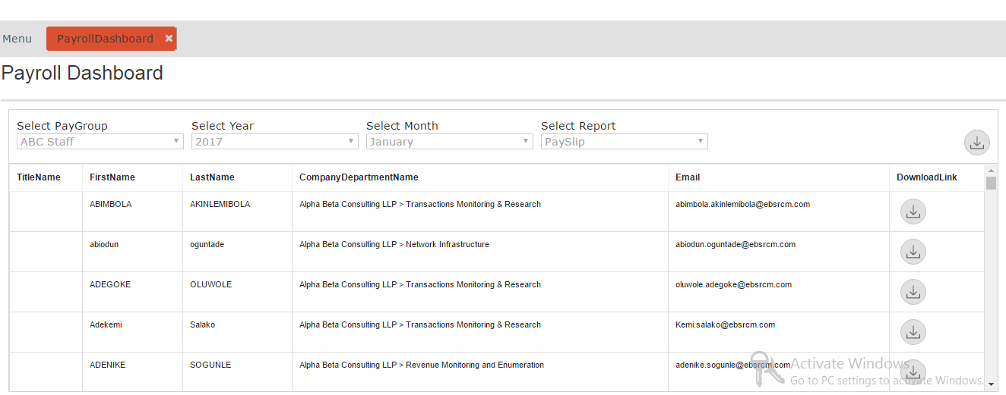

- The pay slips can be downloaded from the result by clicking on the Download Link icon.
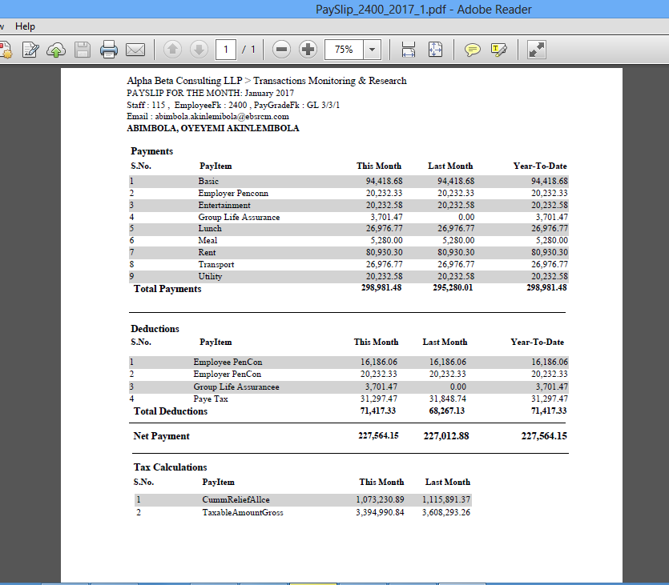
- Next Step to generate the Bank Remittance click on Bank Remittance Report from the left menu tab , then click on the Bank Remittance Report and report can be viewed in the view.

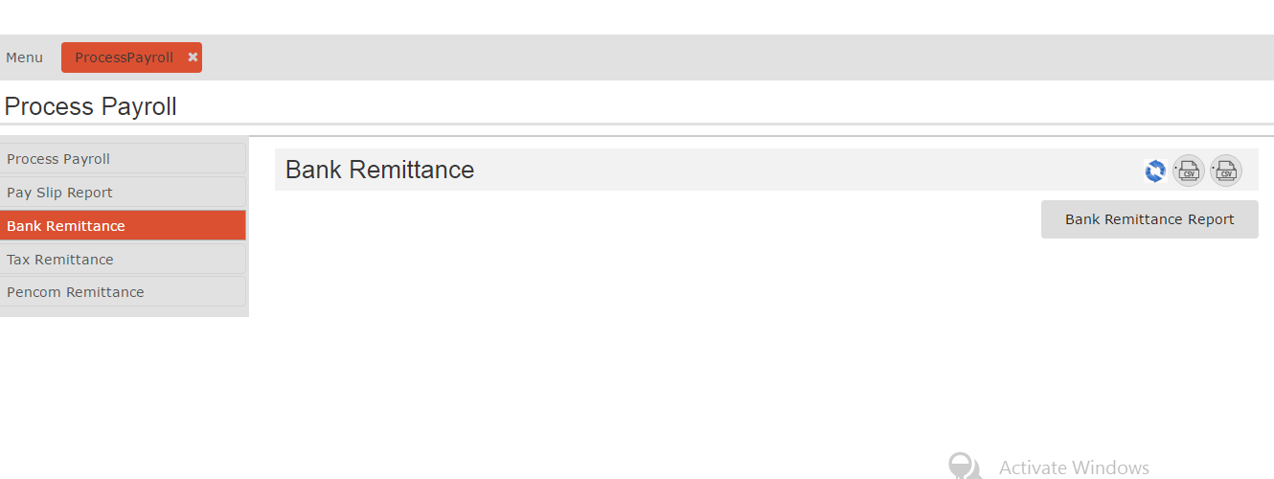

- The Bank Remittance report is displayed on the view, which can be downloaded as PDF and CSV formats from the icon on the right side.
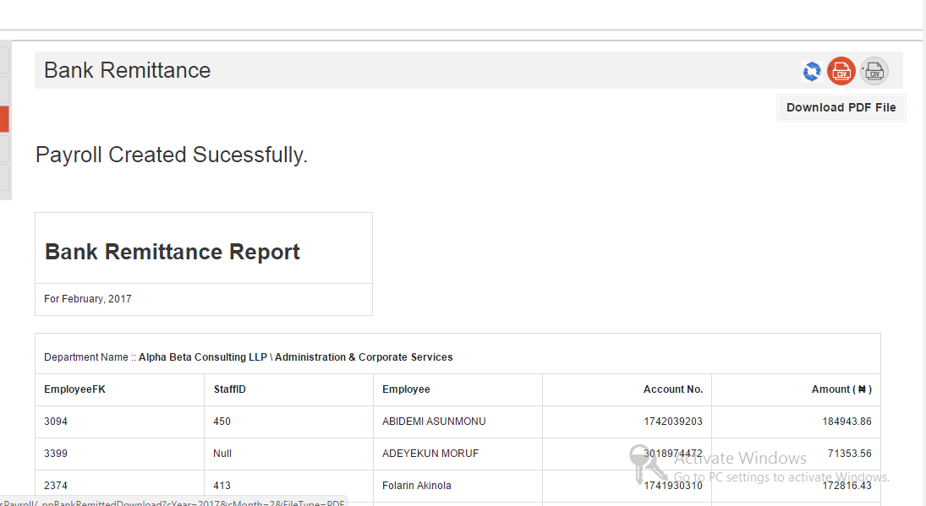

- Below is the sample of Bank Remittance report :
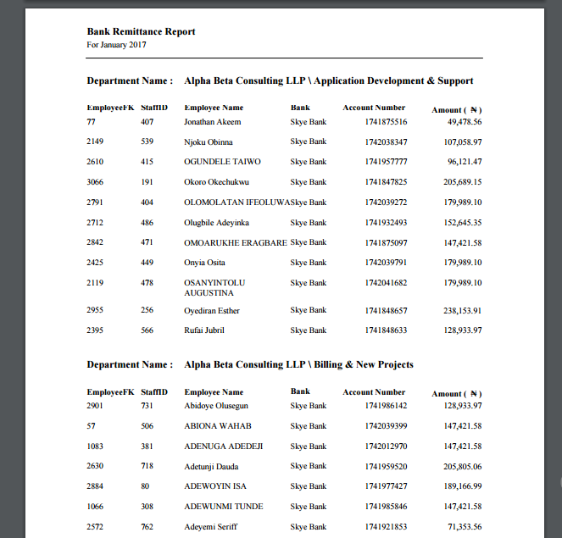

- Next Step to generate the Tax Remittance click on Bank Remittance Report from the left menu tab, and then click on the Bank Remittance Report and report can be viewed in the view.

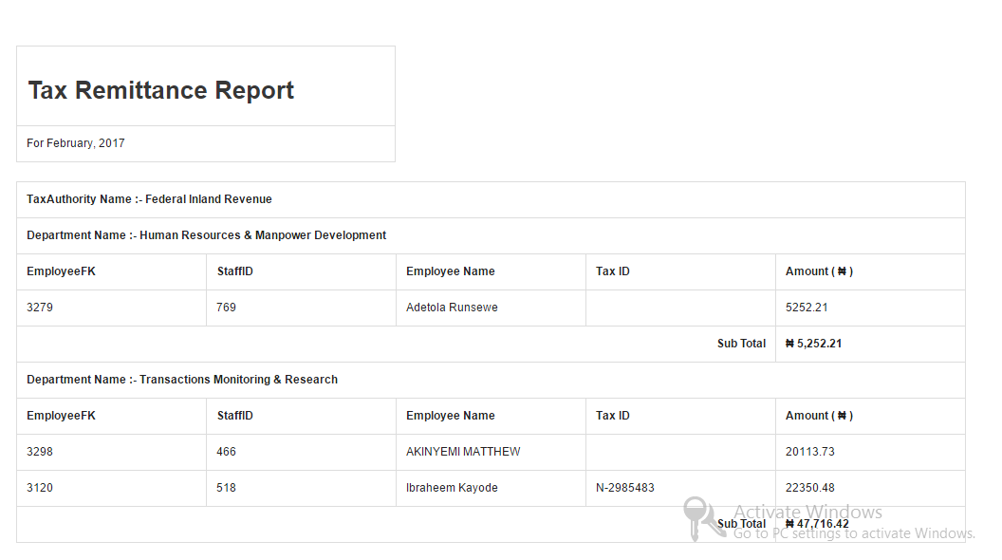

- The Tax Remittance report is displayed on the view, which can be downloaded as PDF and CSV formats from the icon on the right side.
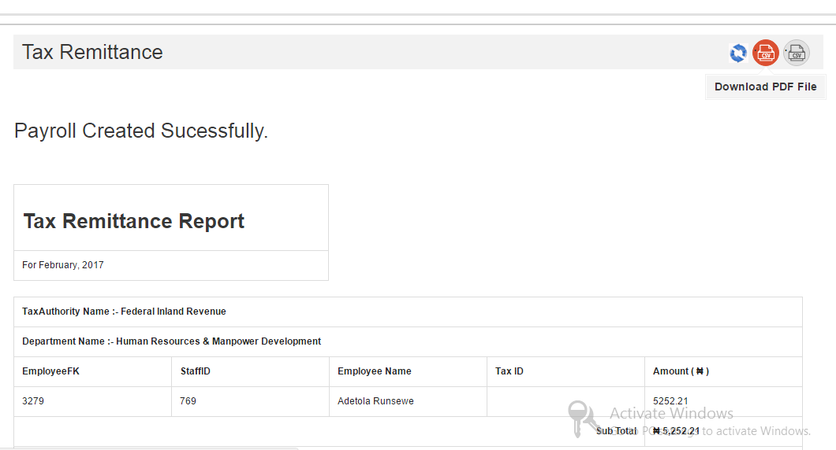

- Below is the sample of Tax Remittance report
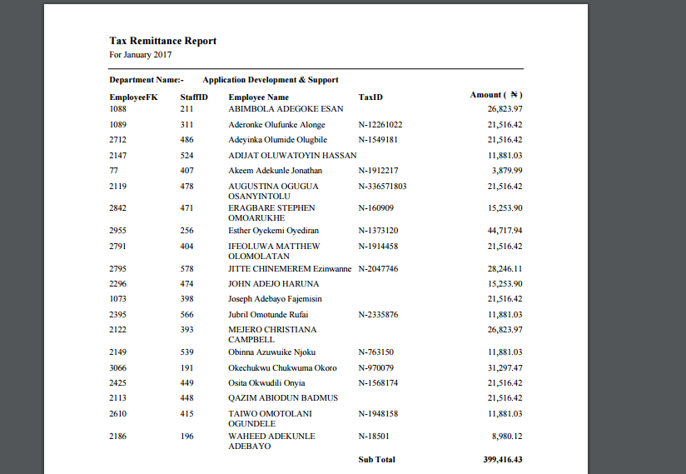
- Next Step to generate the Pencom Remittance click on Pencom Remittance Report from the left menu tab, and then click on the Pencom Remittance Report and report can be viewed in the view.

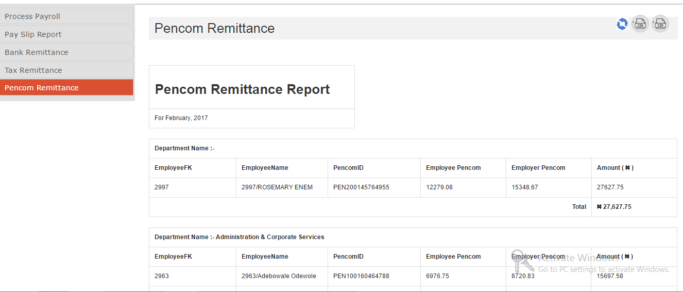

- The Pencom Remittance report is displayed on the view, which can be downloaded as PDF and CSV formats from the icon on the right side. Here’s is a sample:
