M anual for GL Report

A general ledger (GL) report is a set of numbered accounts a business uses to keep the track of its financial transactions and to prepare financial reports. Each account is a unique record summarizing each type of asset, liability, equity, revenue and expense. Following are the steps to get the GL Reports:
- After login in Infiniti client, change role to Manager.
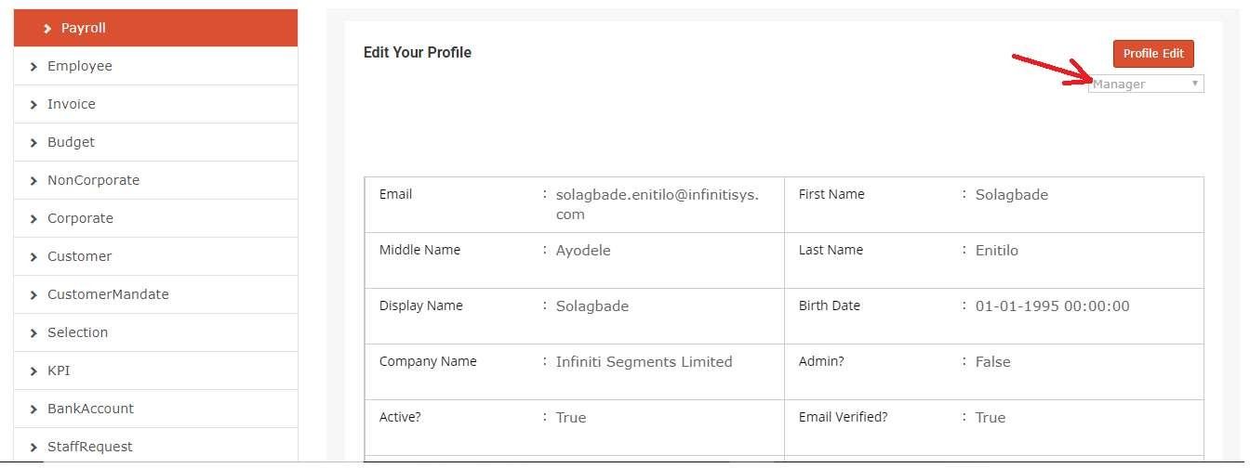

- To get the GL Report menu follow the below mentioned steps :
  - Go to Admin Panel
  - Select Report from left panel
  - Now choose GL Report from right Panel (marked with Arrow)

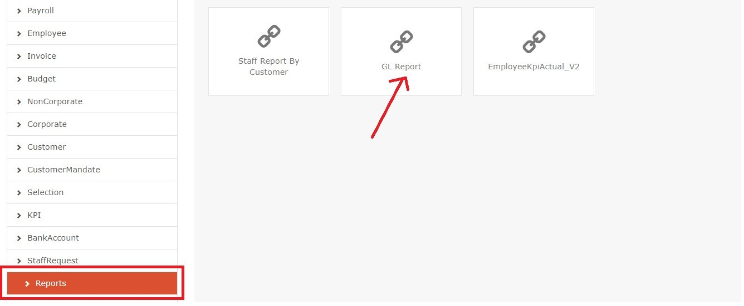

- To generate the GL Report, Select Report date and currency and after that user needs to click on “Get Report” button.
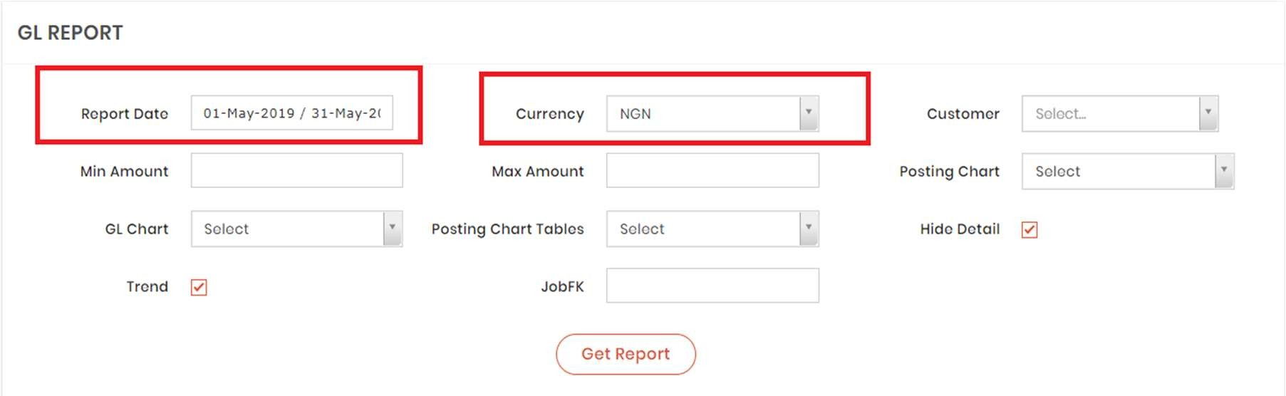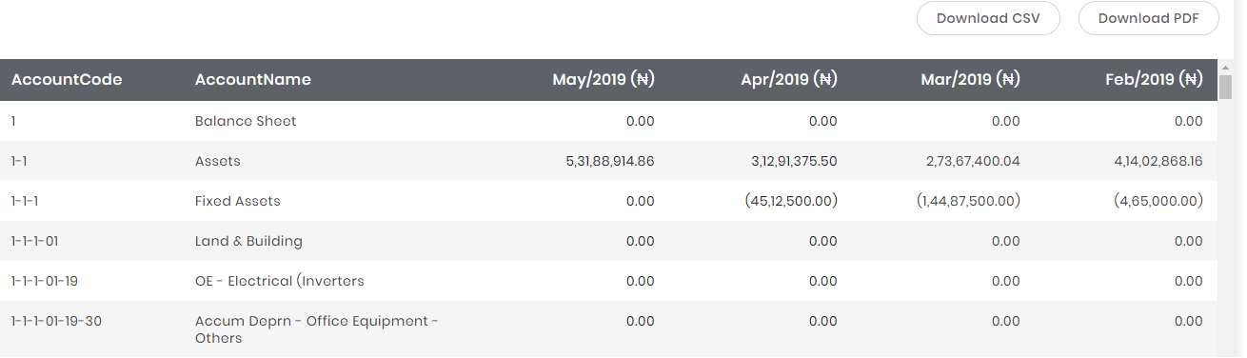

- If user wants to check GL Report of particular Account Code, then please select Account Code from GL Chart dropdown:
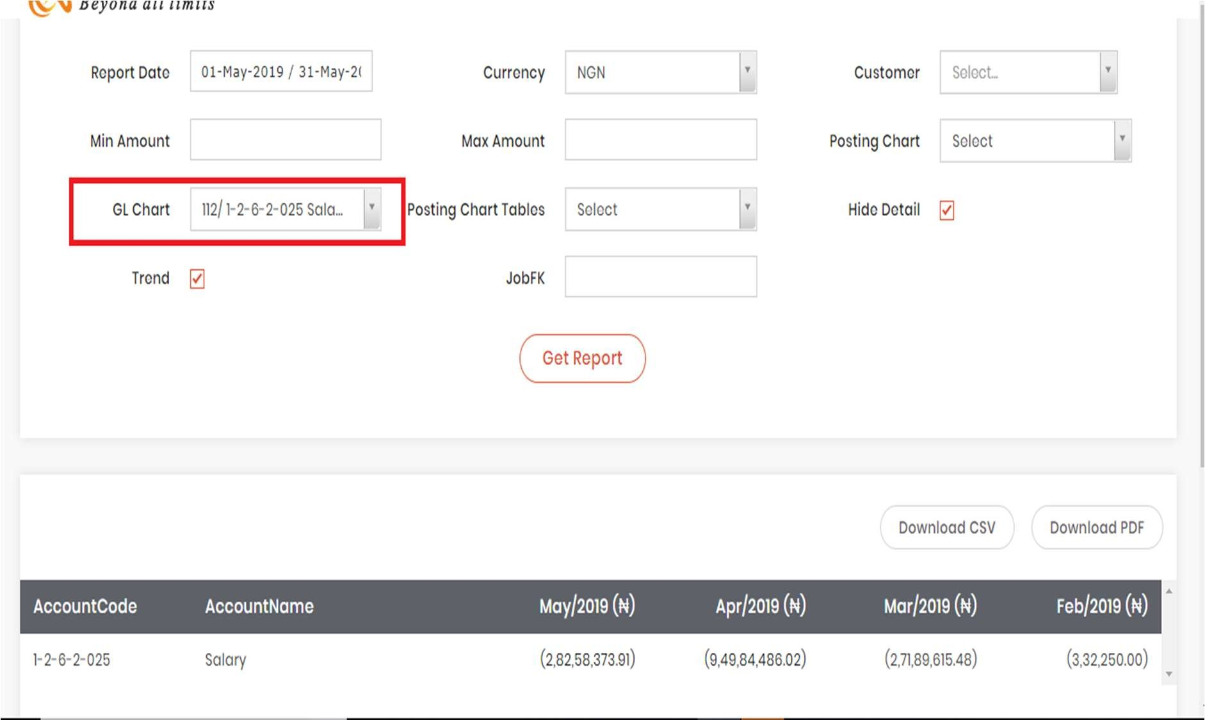

- If user wants to generate GL Report based on Posting Chart Tables, please select table name from Posting Chart Tables dropdown:
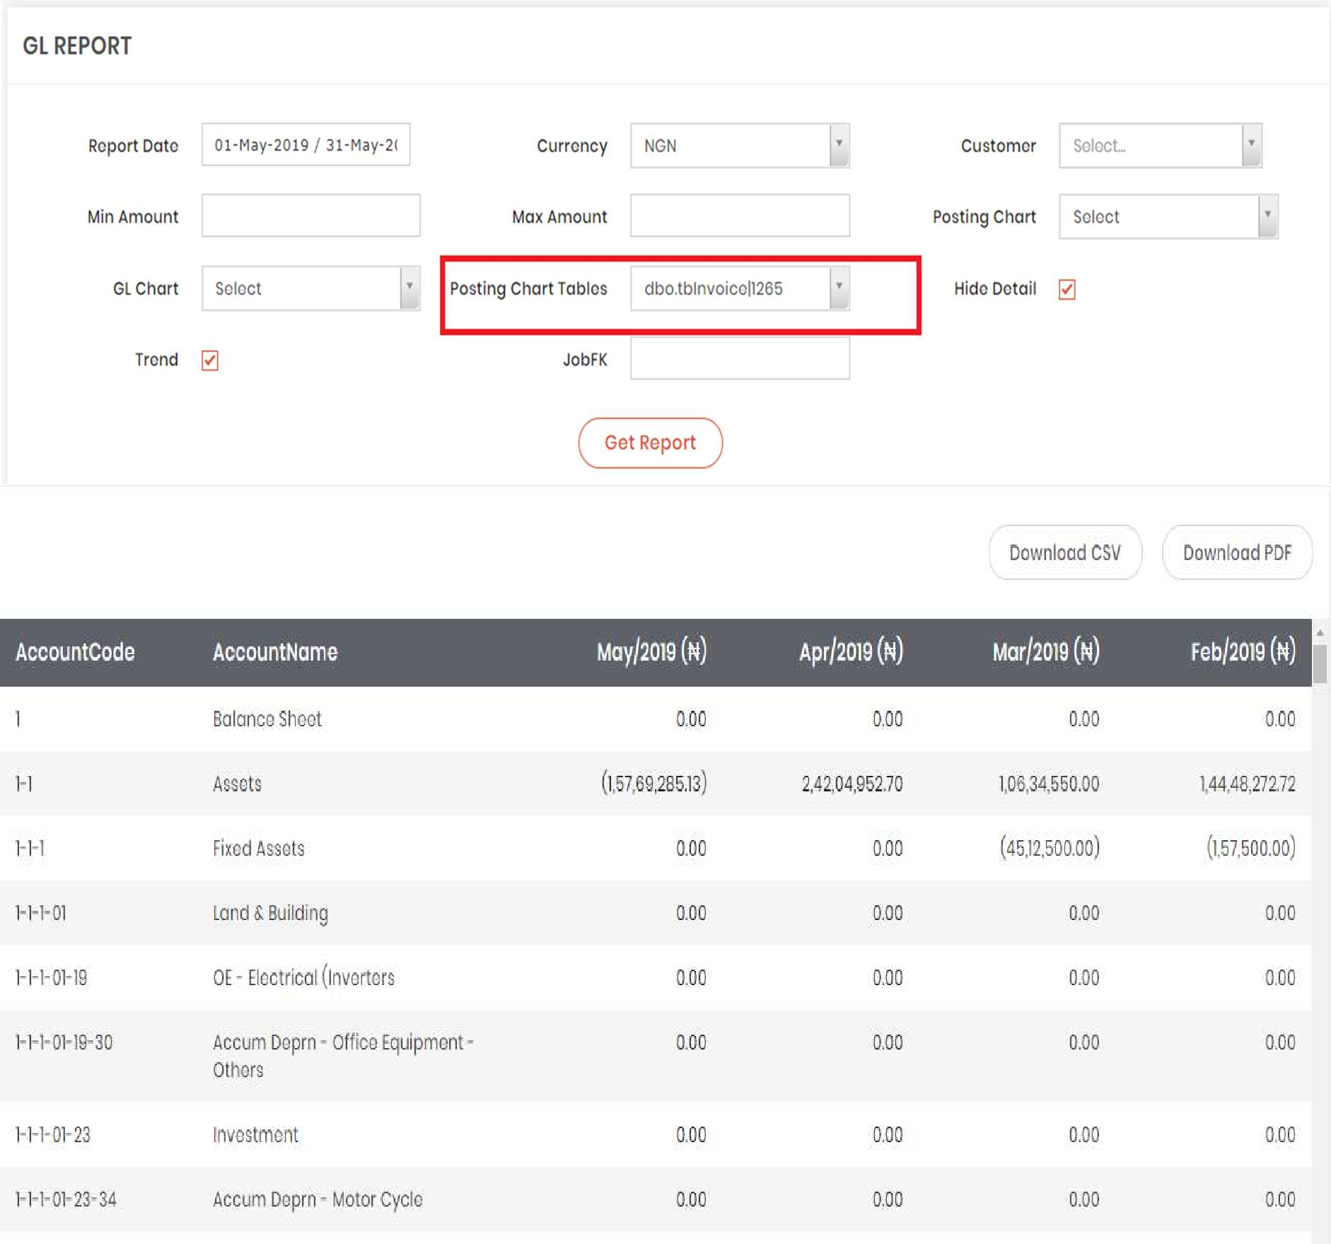

- If user wants to generate GL Report based on particular Posting Chart, user can choose data from Posting Chart dropdown to show all data in hierarchy for selected posting chart:
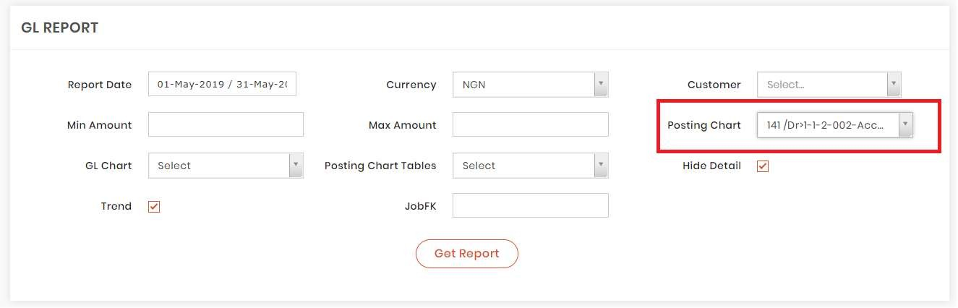

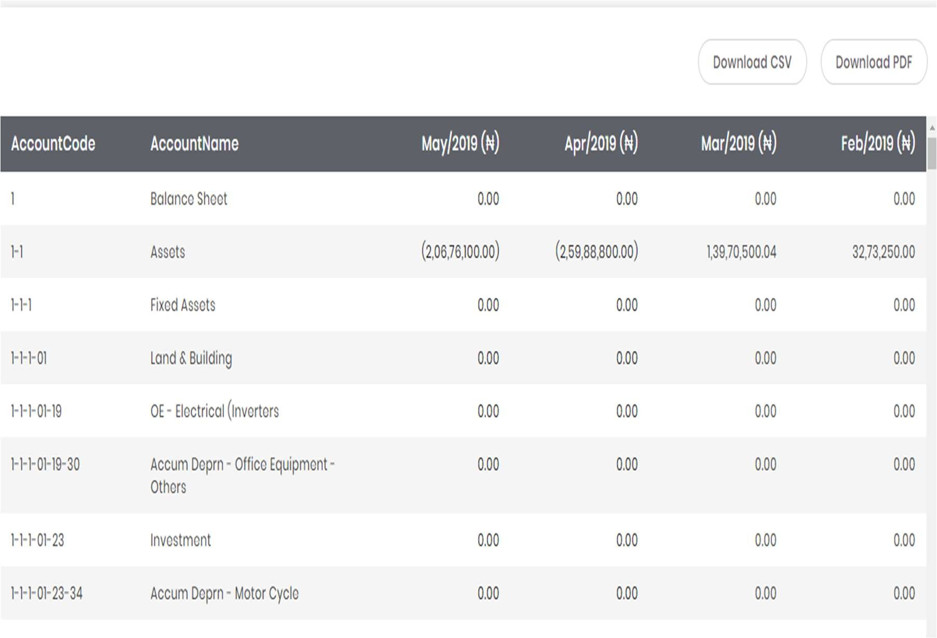

- If user wants to generate GL Report based on specific Customer, user can select from
Customer dropdown to show all account code in hierarchy for selected filter:
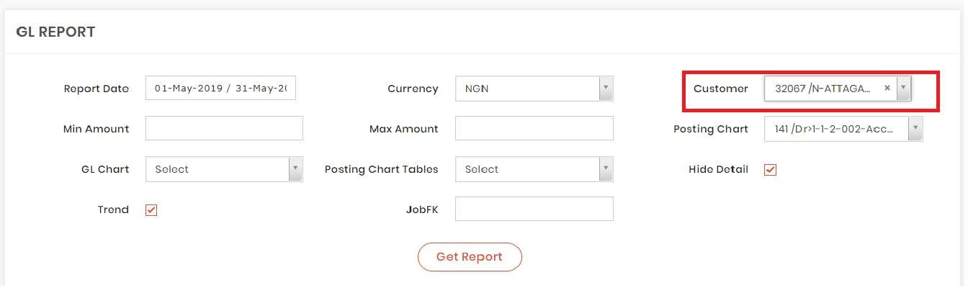

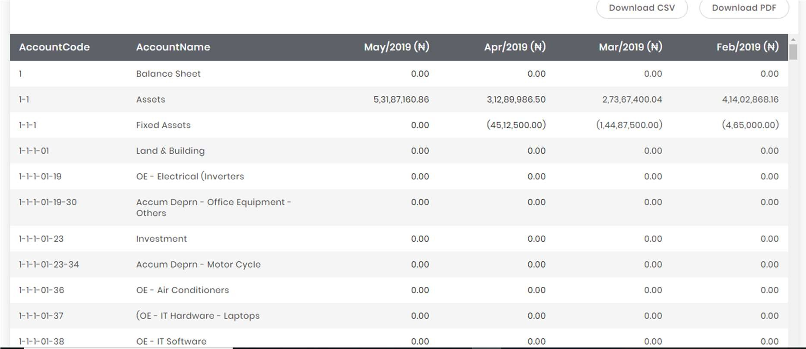

- User can generate detailed GL report by deselecting “Hide Detail” checkbox and to get the report user needs to click on “Get Report” button and the report will be looked as follows :
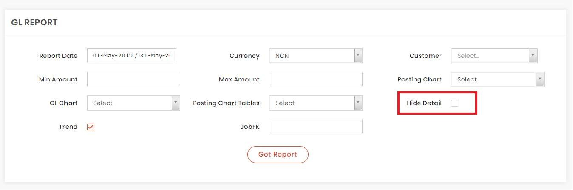

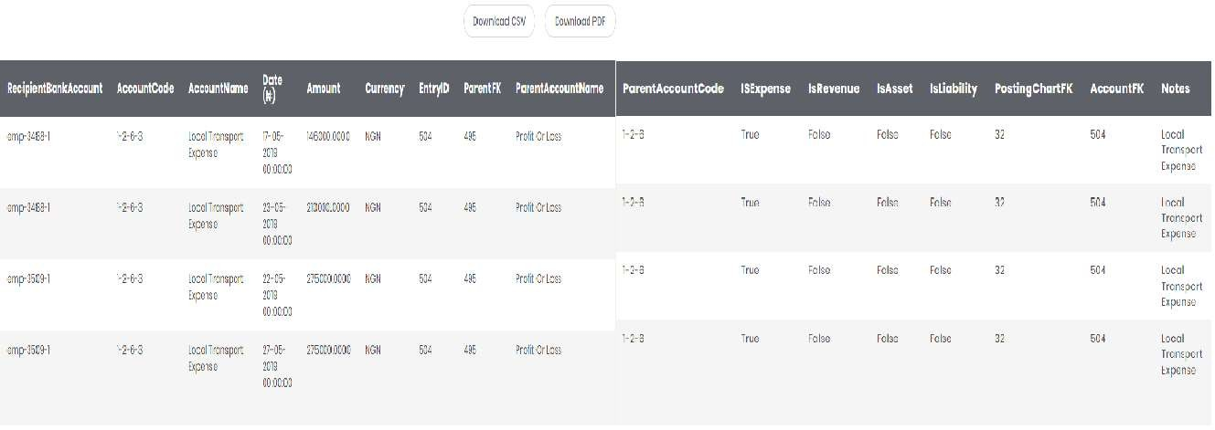

- GL Report will show monthly data in default . When user wants to generate yearly report ; he has to deselect Monthly Report and select Yearly Report he can generate last four years’ report.

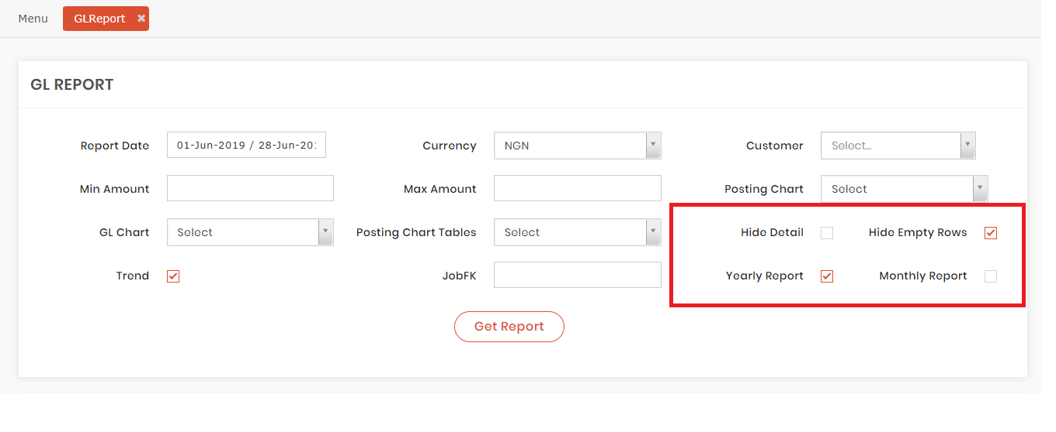

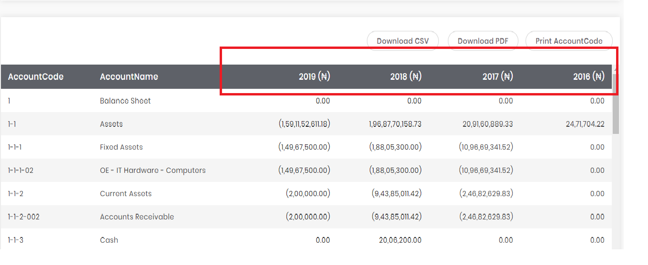

- User can hide empty rows by selecting Hide Empty Rows checkbox.
If user deselecting this checkbox the report will look like as follows :

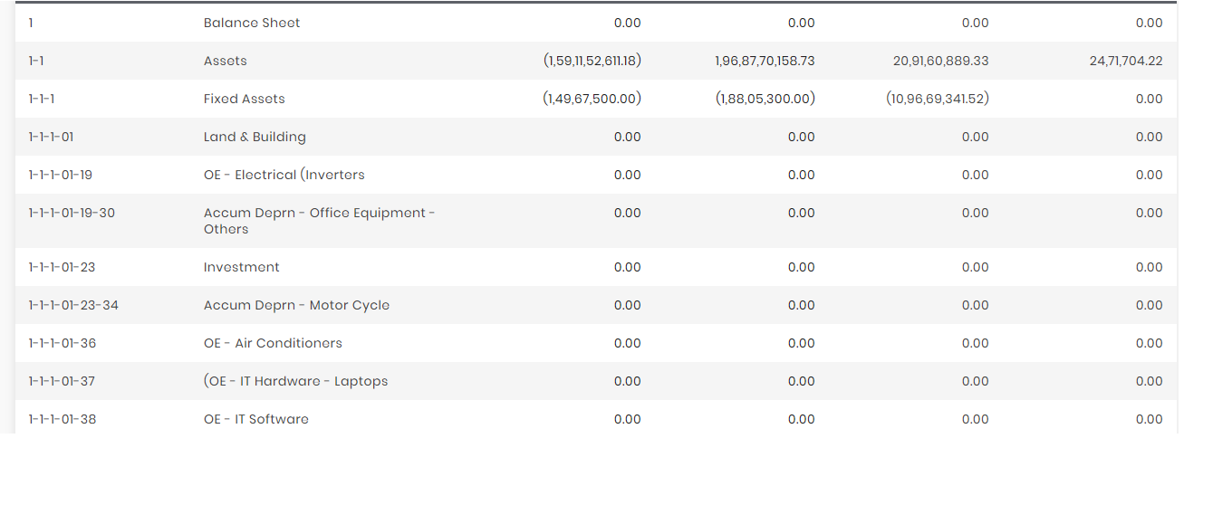

If user selects Hide Empty Rows Check Box the report will look like following :

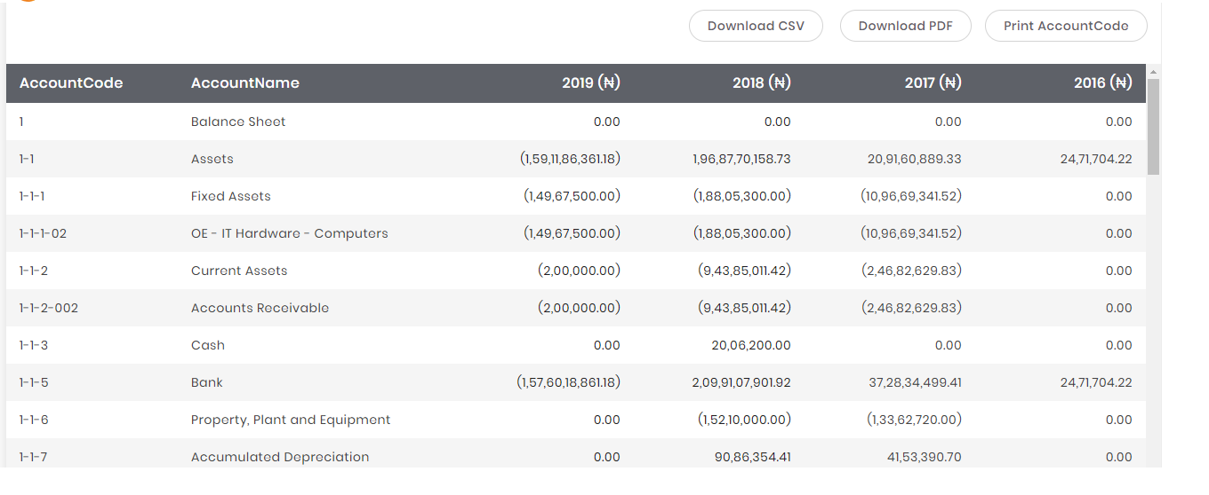

- User can print only Account Code and Account Name from generated GL Report by clicking on Print Account Code Button .

After clicking 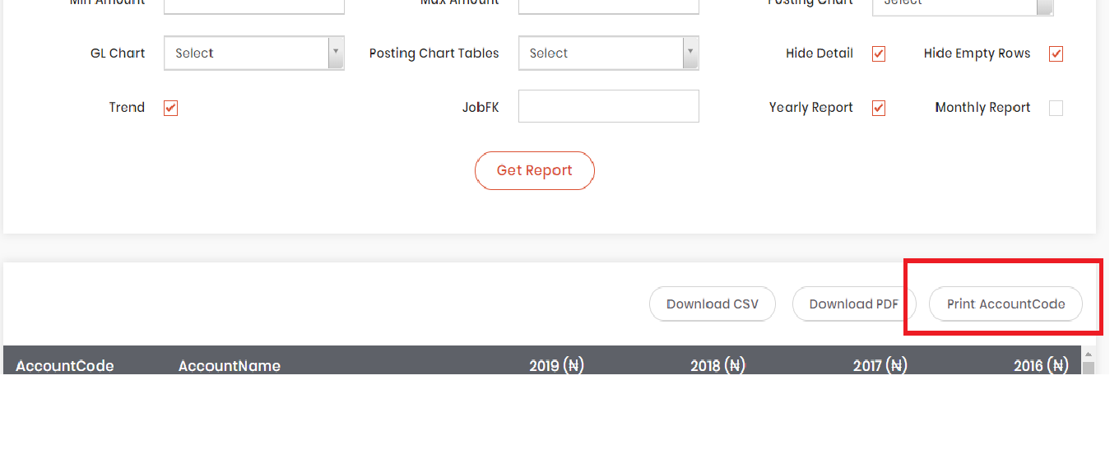

After clicking on Print Account Code Button it will open a new window which look like as follows :
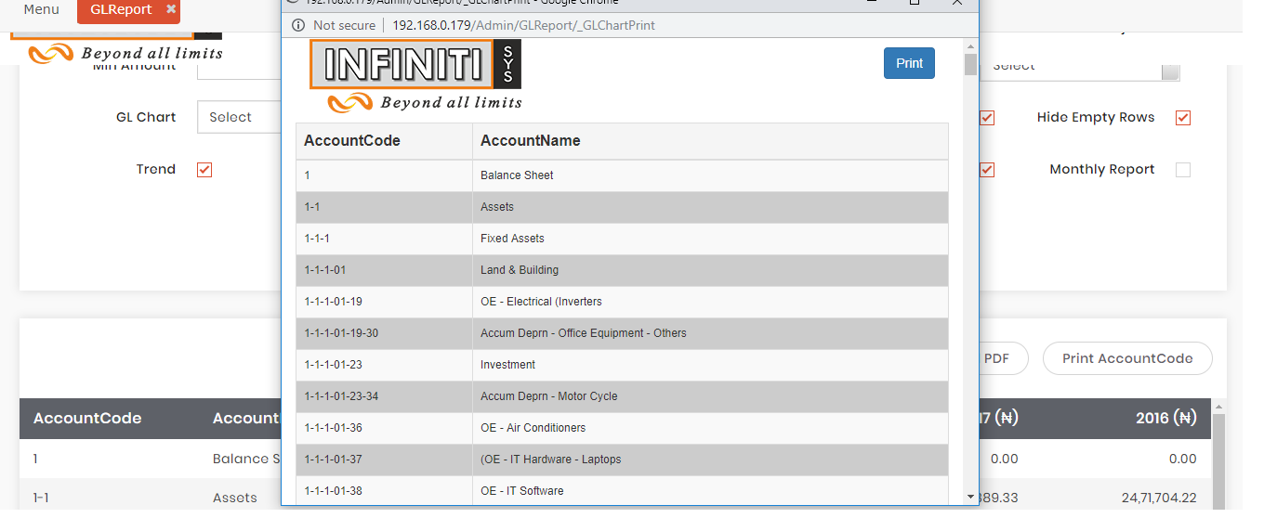

To print it user needs to click on Print Button . It will open print dialog box where user can print it .

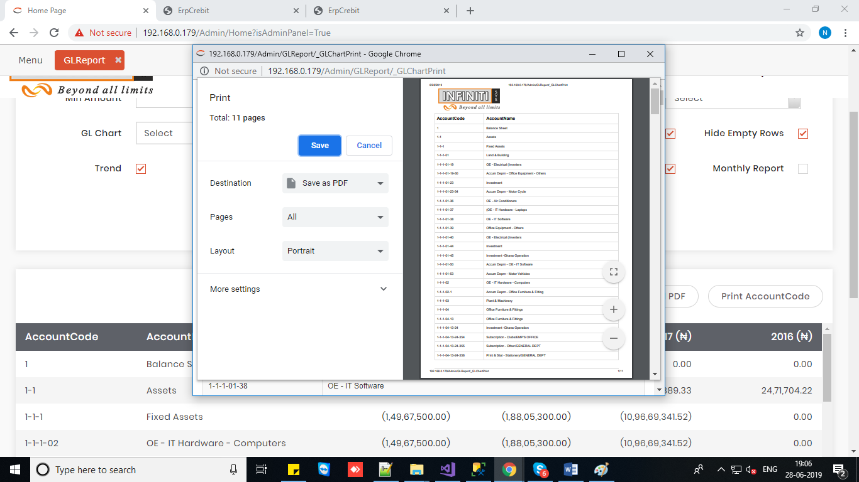
- User can download the GL report in pdf or excel format by clicking “Download PDF” or ”Download CSV” button which will be looked like as below :
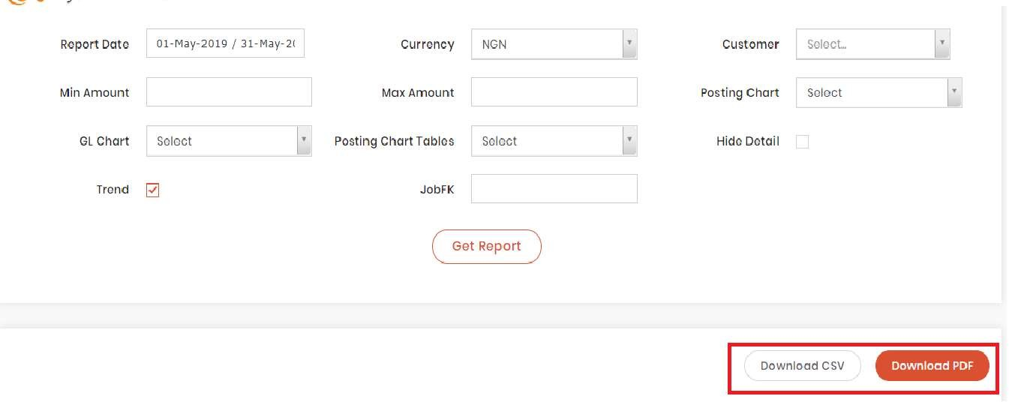
Report in PDF Format:
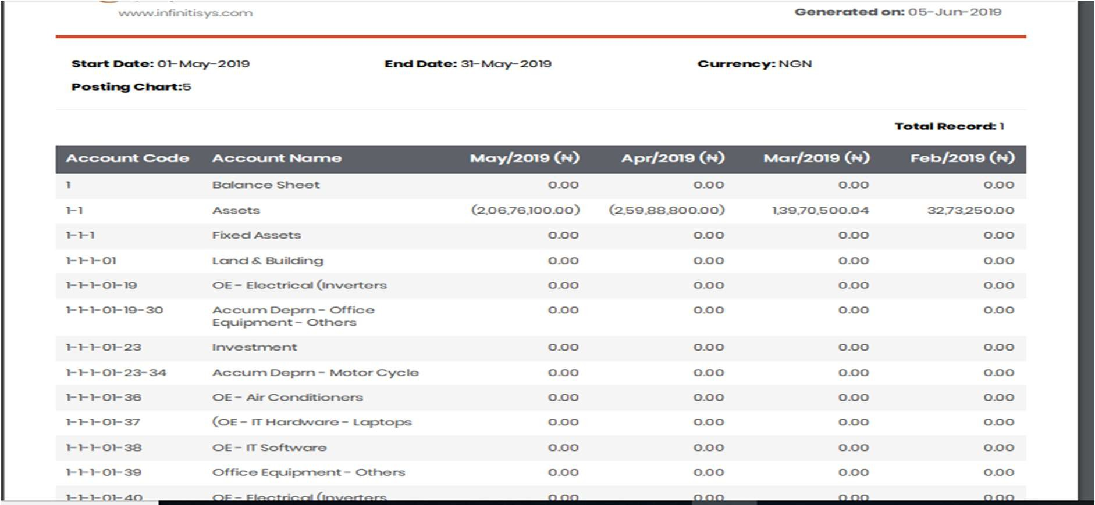

Report in Excel Format:
